# PHYS1001 – PL5. Ideal Gas Law

|  |  |  |  |
| --- | --- | --- | --- |
| Name: | Samuel Allpass | Lab Stream: | **PRA1-** |
| Student Number: | 48030504 | Date: 15/5/24 |  |
| Other Group Members | Dakota Bailey, Emily Cooke | |  |

**Your worksheet will be given a Satisfactory/Unsatisfactory mark. To hand in your work, upload your worksheet at the Blackboard link under Learning Resources** *>* **Laboratory /Practicals.**

1. **If you are finished in class, first show your worksheet to your tutor for on-the-spot marking, then upload your worksheet (we need this for record-keeping).**
2. **If you are not finished by the end of class, you must show your work to your tutor and ask for permission to upload your worksheet after class for marking and record-keeping. If you are granted permission, you have 24 hours after the end of your class to do so.**

|  |  |
| --- | --- |
| **Today’s aim:** | Interpret and communicate experimental results |
| **Overall mark:** | **Satisfactory (1)** □ **/ Unsatisfactory (0)** □ |

A satisfactory submission will generally exhibit the following criteria - if unsatisfactory, tutors will indicate which are missing:

* Communication & Presentation
  + Neat presentation and intelligible writing
  + Clear calculations
  + Clear writing, logical flow of ideas, and good grammar.
  + Coherent data presentation in tables and graphs with suitable labelling. **–** Completeness
* Scientific Method
  + Quality of data and record keeping indicates appropriate care in experimental process
  + Methods used are appropriate for the experiment
* Uncertainty
  + Uncertainties in raw data estimated and **justified**.
  + Correct use of significant figures and units.
  + Propagation of uncertainties.
* Analyse & Assess
  + Analyse the data and come to correct scientific conclusions
  + Critical evaluation of results
* Actively contributed to group (noting that participation looks different for everyone)
* Presented original work

If you receive a mark of Unsatisfactory, please email phys1001@uq.edu.au to book a time for another attempt!

# A Practical Lab 5 – Thermodynamics

In this lab we will be exploring the Ideal Gas Law.

## A.1 Learning Objectives for this Practical Lab

Physics concepts you will use:

* Temperature
* The Ideal Gas Law
* Thermal equilibrium
* Dimensional analysis

Lab skills you will practice:

* Uncertainty estimation
* Interpreting graphs
* Written communication

This laboratory is inspired by the collaborative efforts in laboratory design at the Advancing Science by Enhancing Learning in the Laboratory workshop, [http://www.asell.org/,](http://www.asell.org/) in particular by Elizabeth Angstmann and Sebastian Frike.

## A.2 EQUIPMENT

The primary goal of this experiment is to determine the number of moles of gas inside a syringe by using the relationship between pressure and volume at constant temperature.

To begin, let’s inspect the equipment we will be using:

1. 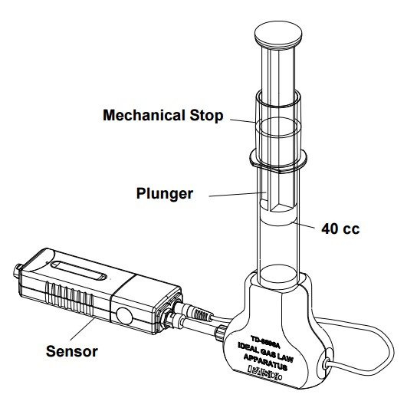PASCO Equipment plunger (here shown with 40 cc indicated, i.e. volume)
2. The syringe hooks up to a pressure and temperature sensor via the blue PASCO sensor which runs into the computer.
3. The prac involves a retort stand with two clamps. The lower one stabilises the syringe.
4. A number of 500 g weights stacked on a stand.
5. The stand itself weighs 500 g and can be used as your first weight.

Figure 1: PASCO Equipment

## A.3 THEORY: The Kinetic Energy-Temperature Connection

The properties of macroscopic systems are determined by the behaviour of their microscopic constituents. When we look at the bulk properties of matter we often model its atoms and molecules as simple rigid spheres. The kinetic energy of those atoms is directly related to the temperature of the macroscopic system. The faster the atoms move or vibrate, the higher the temperature of the object.

### *Pressure*

In a gas, the particles are very loosely bound to each other and are able to move randomly and collide with each other. They also collide with the walls of their container. We measure this collective motion as pressure.

### *The Ideal Gas*

In physics we often make “ideal” gas models. An ideal gas is one whose particles only interact via perfect elastic collisions with each other and any boundaries (walls of the container, etc.).

### *The Ideal Gas Law*

The pressure *P*, volume *V* , temperature *T* and amount of gas in a system are all interrelated. If we change one of these variables, the others will change in response. The equation which relates these variables and describes an ideal gas is

*PV* = *nRT*

where *R* is the universal gas constant, and *n* is the number of moles of gas in the system. We call this the Ideal Gas Law.

Note: For an intro to this theory see section 18.7 of the textbook, Ideal Gas Processes (and the first Law). If you need help ask your prac tutor or other course staff.

|  |
| --- |
| **Box 1: Theory - Dimensional Analysis.**  We will model the air inside the syringe as an ideal gas, using the Ideal Gas Law equation. Perform a dimensional analysis on the Ideal Gas Law equation to find the units of the universal gas constant R. Begin by listing the appropriate units for each of the other variables. Use base SI units.  Pressure: [P] =  Volume: [V] =  Number of moles of gas: [n] =  Temperature [T] =  [R] = |

|  |
| --- |
| **Box 2: Theory – Linearisation**  In the experiment you will be adjusting the pressure P and volume V of the gas (at constant temperature T) in order to calculate the number of moles of gas inside the syringe. To make this calculation you will perform a linear regression. Rewrite the ideal gas law equation so that pressure is a function of volume. Is this equation in a linear form (y = mx + c)? If not, linearise it now and write which variables correspond to y, x, m, and c:    What will you need to do to calculate the number of moles of gas inside the syringe from your linear regression? |

|  |
| --- |
| **Box 3: Theory - Thermal equilibrium**  During the experiment you will need to wait for the system to return to thermal equilibrium before taking each new set of measurements.  Firstly, what does it mean to be in thermal equilibrium?  When an object is in thermal equilibrium, its state values, pressure, volume and temperature are said to reach steady unchanging values.  Secondly, why do we care about our system being in thermal equilibrium while we are taking measurements during this lab?  We want out system to be in thermal equilibrium so that the state values are unchanging as we attempt to measure them, making for more accurate readings. |

## A.4 ESTIMATES

Here you will make theoretical estimates which you can later compare with your experimental results.

|  |
| --- |
| **Box 4: Estimate of** *n*  In your experiment, the starting volume of the syringe will be 60 mL. How many moles of gas should you expect to be in your syringe?  Hint: At room temperature and pressure, 1 mol ideal gas is equal to 24.5 L.    Compare this estimate with your experimental result during the discussion part of this workbook. |

In order to adjust the pressure and volume of the gas during the experiment, you will add weights on top of the syringe plunger. Doing so will exert a force on the plunger which will then compress the gas causing a change in pressure. Pressure is defined as the amount of force exerted over a given surface area:

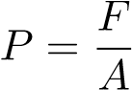

|  |
| --- |
| **Box 5: Estimate of pressure change**  Calculate the change in pressure you would expect after placing a 1.5kg mass on the syringe. To do this you will need to use the vernier callipers provided to measure the internal diameter of the syringe. This will allow you to determine the surface area over which the force will be applied. Remember to record (and justify) uncertainties in your measurement.    Compare this estimate with your experimental result during the discussion part of this workbook. |
|  |

**CHECKPOINT: Stop here and describe your estimates to a tutor before proceeding.**

A.5 METHOD

You will need to record the pressure, temperature and volume of the air in the syringe, for each mass listed in Table 1. In your method remember to briefly justify why you have made certain decisions, and don’t forget to justify any uncertainties.

|  |
| --- |
| **Box 6: Method**  In order to calculate the number of moles of air in the syringe, as was derived above, we will need to know the pressure, temperature and volume of the syringe at each mass added. The system was setup using a retort stand that guided a mass to the top of a syringe, such that it compressed. The syringe was connected to a volume and temperature recording device which displayed the data on PASCO. It was known that the uncertainty in the pressure and temperature of syringe were ±2kPa and ±0.5K respectively. As the number of moles would be respective of the gradient of a pressure (Pa) vs inverse volume graph, it was concluded that only the change in mass would be important in calculations and thus the mass holding rod could be our start mass of 0kg. In addition to this the uncertainty in the mass would be extremely insignificant compared to other uncertainties and thus it was considered negligible. The volume of the gas was to be measured using the scales on the syringe.  These date recordings would then be used to plot a pressure vs inverse volume graph, meaning the number of moles would be calculatable according to: |

**CHECKPOINT: Stop here and describe your methods to a tutor before proceeding.**

## A.6 RESULTS

Perform the experiment and record your results in Table 1. Remember to record uncertainties for each measurement, and consider the significant figures you will need.

**Table 1: Experimental Results**

|  |  |  |  |  |
| --- | --- | --- | --- | --- |
| Mass added (kg) | Pressure (kPa) | Temperature (K) | Volume (mL) | 1/Volume (mL^-1) |
| 0 | 105.99 | 301.2 | 58 | 0.017241379 |
| 0.5 | 111.015 | 301.21 | 55 | 0.018181818 |
| 1 | 117.834 | 301.16 | 52 | 0.019230769 |
| 1.5 | 124.035 | 301.04 | 50 | 0.02 |
| 2 | 132.827 | 300.99 | 46 | 0.02173913 |
| 2.5 | 138.433 | 300.94 | 44 | 0.022727273 |
| 3 | 139.178 | 300.91 | 44 | 0.022727273 |

|  |  |
| --- | --- |
| 1/Volume (L^-1) | Pressure (Pa) |
| 17241.37931 | 105990 |
| 18181.81818 | 111015 |
| 19230.76923 | 117834 |
| 20000 | 124035 |
| 21739.13043 | 132827 |
| 22727.27273 | 138433 |
| 22727.27273 | 139178 |

|  |  |
| --- | --- |
| average temperature | 301.0642857 |
| Temperature uncertainty | 0.15 |

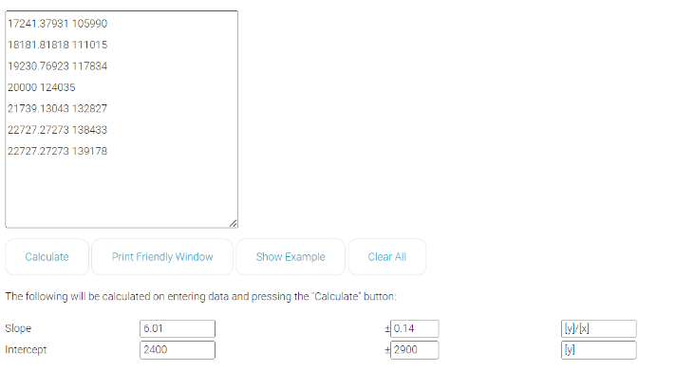

**Table 2: Results from Linear Regression**

|  |  |
| --- | --- |
| y-axis variable  (uncertainty and units) | Pressure (Pa). Uncertainty: 2kPa |
| x-axis variable (uncertainty and units) | 1/Volume (1/Liters). Uncertainty: 0.5L |
| Gradient  (uncertainty and units) | *m* = (6.01 ± 0.14) Joules |
| Intercept  (uncertainty and units) | *c* = (2400±2900) Pa |

## A.7 ANALYSIS

|  |
| --- |
| **Box 7: Compute pressure change**  Using your results above, compute the change in pressure observed when you added the 1.5kg mass to the syringe. You will compare this result to your previous theoretical estimate during the discussion below.  The change in pressure from a mass of 0 to a mass of 1.5kg was calculated to be: |

|  |
| --- |
| **Box 8: Compute n**  Using your results above, calculate the number of moles of gas, n, inside the syringe. Hint: make sure you are keeping track of the units being used! |

## A.8 DISCUSSION

In your discussion you should answer the following questions:

1. What was your experimental value for *n* (with uncertainty and units) and how does this compare with your theoretical estimate from Box 4? Suggest a reason for any discrepancy.
2. How does your observed change in pressure when you added the 1.5kg mass compare with your theoretical estimate from Box 5? Suggest a reason for any discrepancy.
3. Which measurements contributed the most to the uncertainty of your final results? How could your method be changed to help reduce the uncertainty resulting from these measurements?
4. In light of your comparisons between theory and experiment, comment on whether you think it was valid to model the air in the syringe as an ideal gas?

|  |
| --- |
| **Box 9: Discussion**  The experiment concluded that the number of moles within the syringe was , a result that very closely resembled the theoretical value of 0.0024 within the uncertainty. In saying this however, when considering that our experimental value for the change in pressure from 0kg to 1.5kg was 18045Pa which lay very far from the theoretical value of 29946Pa, it is concludable that although our values for pressure were very inaccurate, they were all inaccurate by the same amount. This suggested an error in our methodology, which was indeed discovered to be the supporting rod was tightened slightly too much, reducing the amount of force pushing against the syringe. Despite this, it was the same tightness for all trials and thus resulted in our pressure and inverse volume trend being unaffected.  It was also concluded, that the gradient in the slope contributed greatest to uncertainty in n as it had the highest relative uncertainty. This indicates that our uncertainty is mostly affected by the uncertainty in the pressure and volume values. The pressure is only better measured with more accurate electrical measuring devices, the volume however was extremely susceptible to human error when using the scale. The overall uncertainty could be reduced by using devices with smaller increment values, or digital devices. Given the air in the syringe followed was predictable according to PV=nRT, it indicated that modelling the air as an ideal gas was valid for this experiment. |
|  |

## A.9 CONCLUSION

As always, your conclusion should:

1. Summarise and state the key results and outcomes of your experiment.
2. Consider how your data links to the bigger picture, *i.e.* how it compared to known results and what this implies.
3. Make a single suggestion that will be the most impactful for future experiments.

|  |
| --- |
| **Box 10: Conclusion**  The aim of this experiment was to calculate a value for the number of moles of air within a syringe. The experiment concluded that that the number of moles within the syringe was , a result that very closely resembled the theoretical value of 0.0024 within the uncertainty. In saying this however, when considering that our experimental value for the change in pressure from 0kg to 1.5kg was 18045Pa which lay very far from the theoretical value of 29946Pa, it is concludable that although our values for pressure were very inaccurate, they were all inaccurate by the same amount.  This prompted the theory that the variance in pressure from that what was theoretically predicted was a result of the upwards force on the mass from the stabilisation rod. In addition to this, the major uncertainty contributors were found to be the pressure and volume measurements, with smaller scales and more accurate digital devices being suggested as improvements to reduce uncertainty.  In the bigger picture, the experiment implied that the air in the tube was validly modelled by the ideal gas equation PV = nRT. In extension to the experiment, it is suggested that investigations into how valid the ideal gas equation is as a model for the air when the system is exposed to higher temperatures and pressures. |

## A.10 EXPLORATION

At the end of this prac your lab tutor will demonstrate both adiabatic (no heat transfer) and isothermal (constant temperature) compression. As a class, record initial and final values for the isothermal compression in Table 3 below.

By drawing lines, match the processes on the left with the corresponding experimental procedure on the right:

adiabatic compression quickly compress plunger

isothermal compression slowly compress plunger

|  |
| --- |
| **Box 11: Exploration**  During isothermal compression the temperature of the system remains constant. This means that *nRT1* = *nRT2* where *1* denotes before and *2* denotes after compression. Employing the ideal gas law both before and after compression implies that *P1V1* = *nRT1* = *nRT2* = *P2V2*. Hence the following relationship between pressure and volume for an isothermal process:  *P1V1* = *P2V2*  Using the results from Table 3 compute:  *P1V1* = 5610 kPA mL  *P2V2* = 5285 kPa mL  Does P1V1 indeed equal P2V2? If not, suggest a reason for any discrepancy.  This experiment suggested that P1V1 was not to P2V2. It is plausible that this discrepancy is due to the air not being validly modelled by the ideal gas equation when pressure and temperatures reach extremes. This proves the suggested extension to the experiment to be justified. |

**Table 3: Experimental Results**

|  |  |  |  |  |
| --- | --- | --- | --- | --- |
|  |  | Pressure (kPa) | Volume (mL) | Temp. (K) |
| Isothermal compression | Initial | 102 | 55 | 27 |
| Final | 151 | 35 | 27 |

**END OF (THE LAST) PRACTICAL LAB 5!**